Assignment 5

Shalaka Jagtap

1. Node -Red configuration

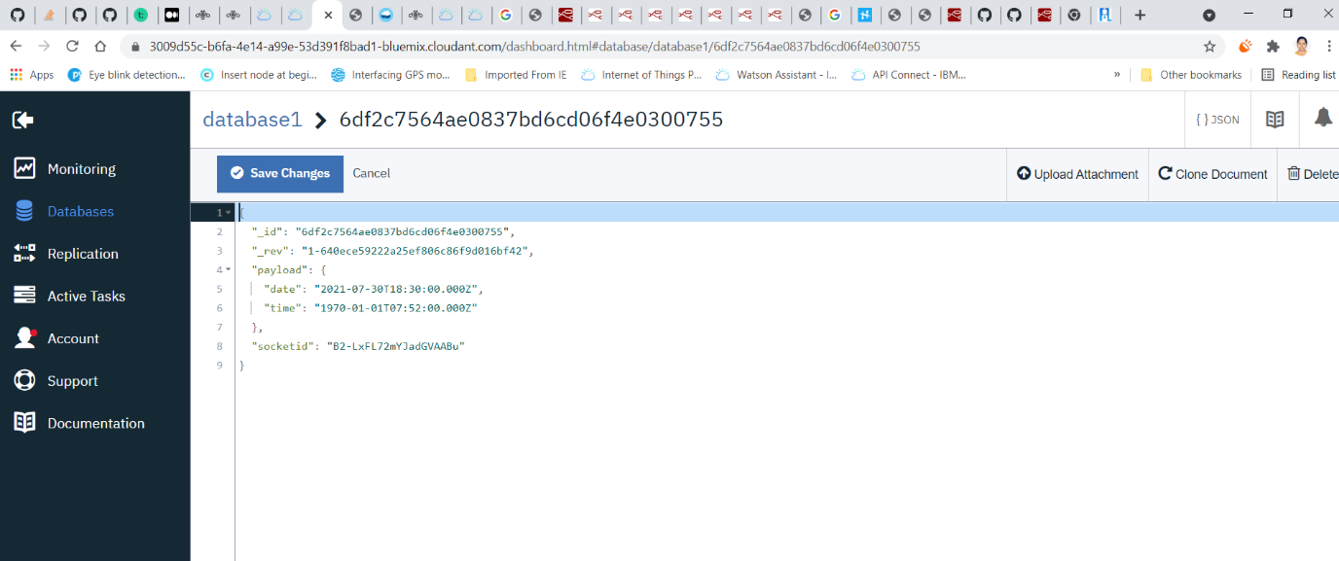

1. Dashboard Output

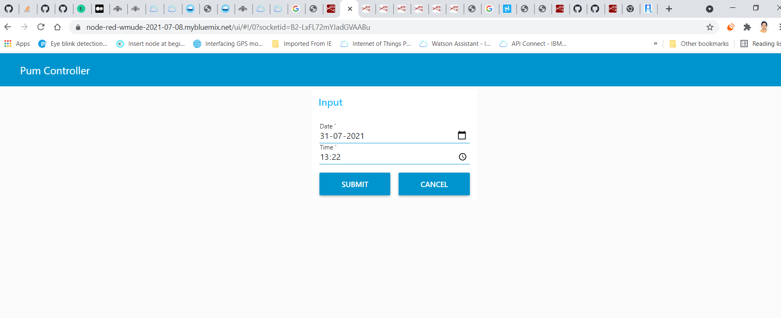

1. Output in Database

